Table of Contents

**A. Request an appointment**

Wireframes…………………………………………………………………………………………………………………………2

**B. Clinic Search**

Wireframes ……………………………………………………………………………………………………………………………6

**C. Medical Services**

Wireframes ……………………………………………………………………………………………………………………………10

1. **Requesting an appointment:**

Requesting an appointment is a feature that allows a user to request for an appointment online. On clicking ‘Appointments’ tab on the main page, the user will be directed to a web form.

To be able to request for an appointment, the user will have to enter his first name, last name, phone number, email address, his regular doctor’s name, the appointment’s date and time and a small description of the appointment. All the input are required fields except the ‘regular Doctors’. If the required fields are not filled, the user will not be able to request for an appointment with the hospital and an error will shown as “* required” beside the field that must be filled.

Upon submitting the form, a success message will appear: *“Thank you for using the online booking system. Your information has been registered. Someone will revert to you as soon as possible for confirmation. For any cancellation, please use the same form or call us on 111-111-11111.”*

**Wireframes:**

**1(i) Public view:**

The figure below shows the visual representation of the request an appointment system.

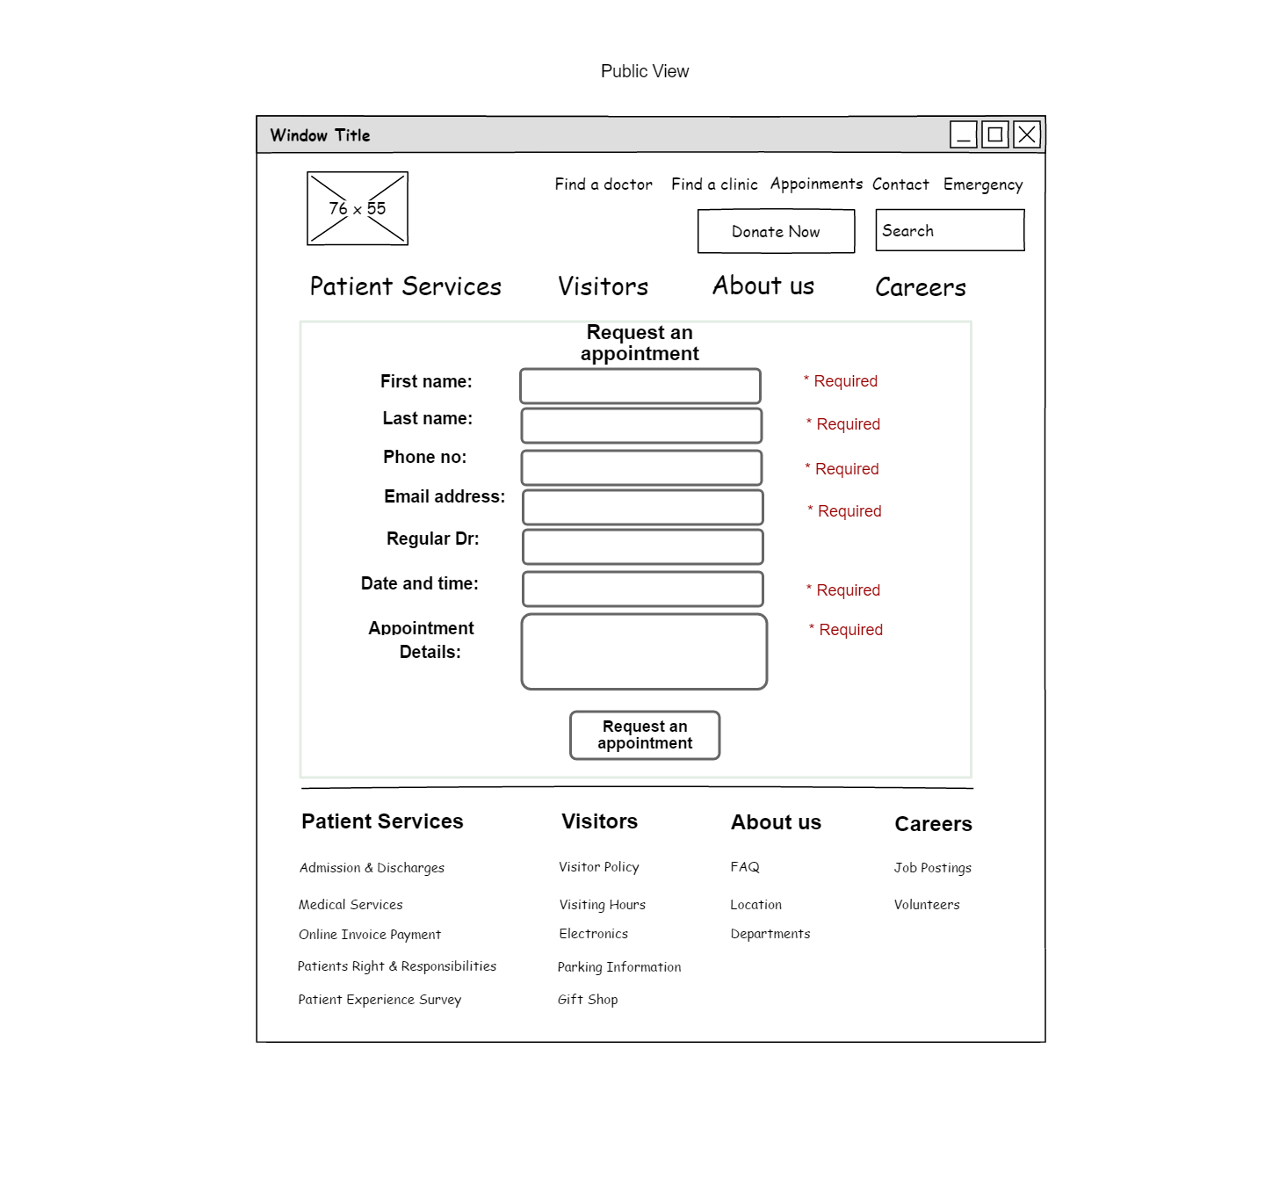

**Fig 1:** Request an appointment wireframe

1. **Find a clinic**

A user can search for clinics and services the hospital offers.

On clicking the ‘Find a clinic’ button on the main page, the user will be shown a webpage where all the list of clinics will be presented to him. On clicking on a specific clinic, detailed information about the clinic will appear on the page. He can use the scroll bar to view all the listed clinics. He can also use the search bar to search for a specific clinic and he will be directed to that clinic on the page. If the user does not know the clinics that the hospital offers, he can also type a word related to the clinic he wants to search for, and he will be directed to the clinic if the hospital provides this type of clinic facility.

The clinics the hospital offers are:

* St Joseph general hospital Elliot lake,
* [St. Joseph's Manor](http://www.sjghel.ca/index.php/volunteer/st-joseph-s-manor),
* The Oaks treatment centre,
* Pet therapy,
* Pastoral care,
* Palliative care.

1. **Public view:** A user is using the search feature to find a clinic

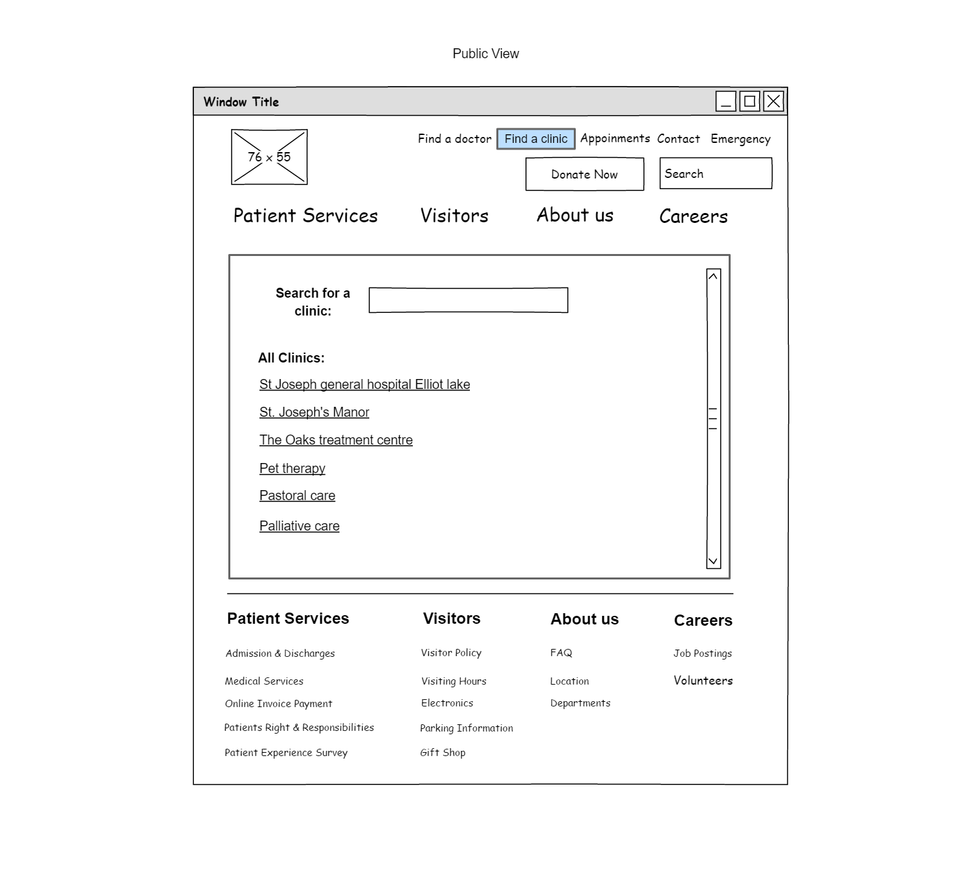

**Fig 2:** Clinic Search wireframe

**(ii) Admin view:** An admin accessing the find a clinic page

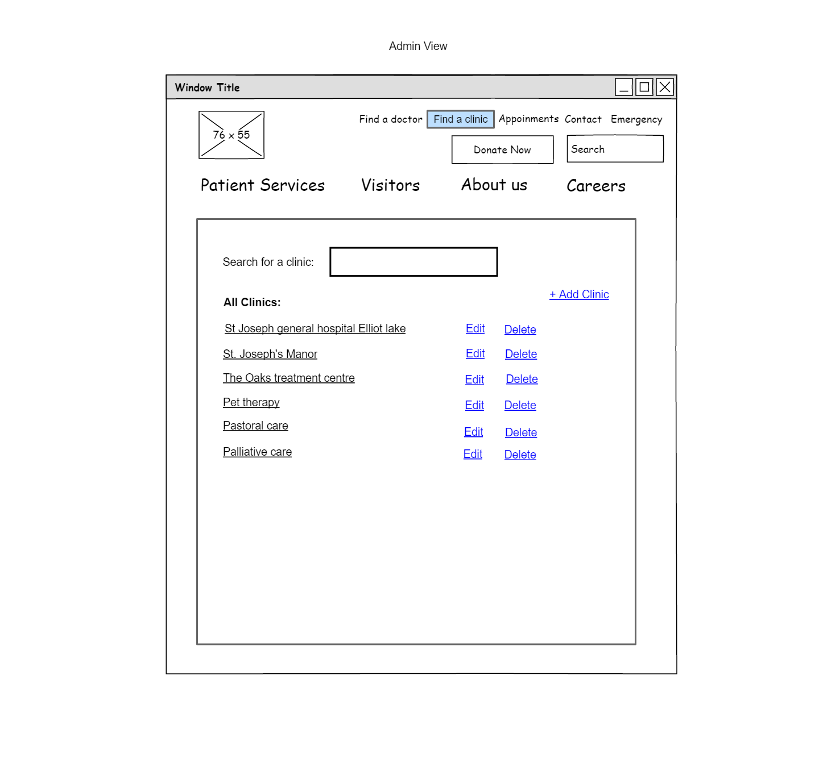

**Fig 3:** Clinic Search admin wireframe

1. **Admin view:** An admin is creating a new clinic

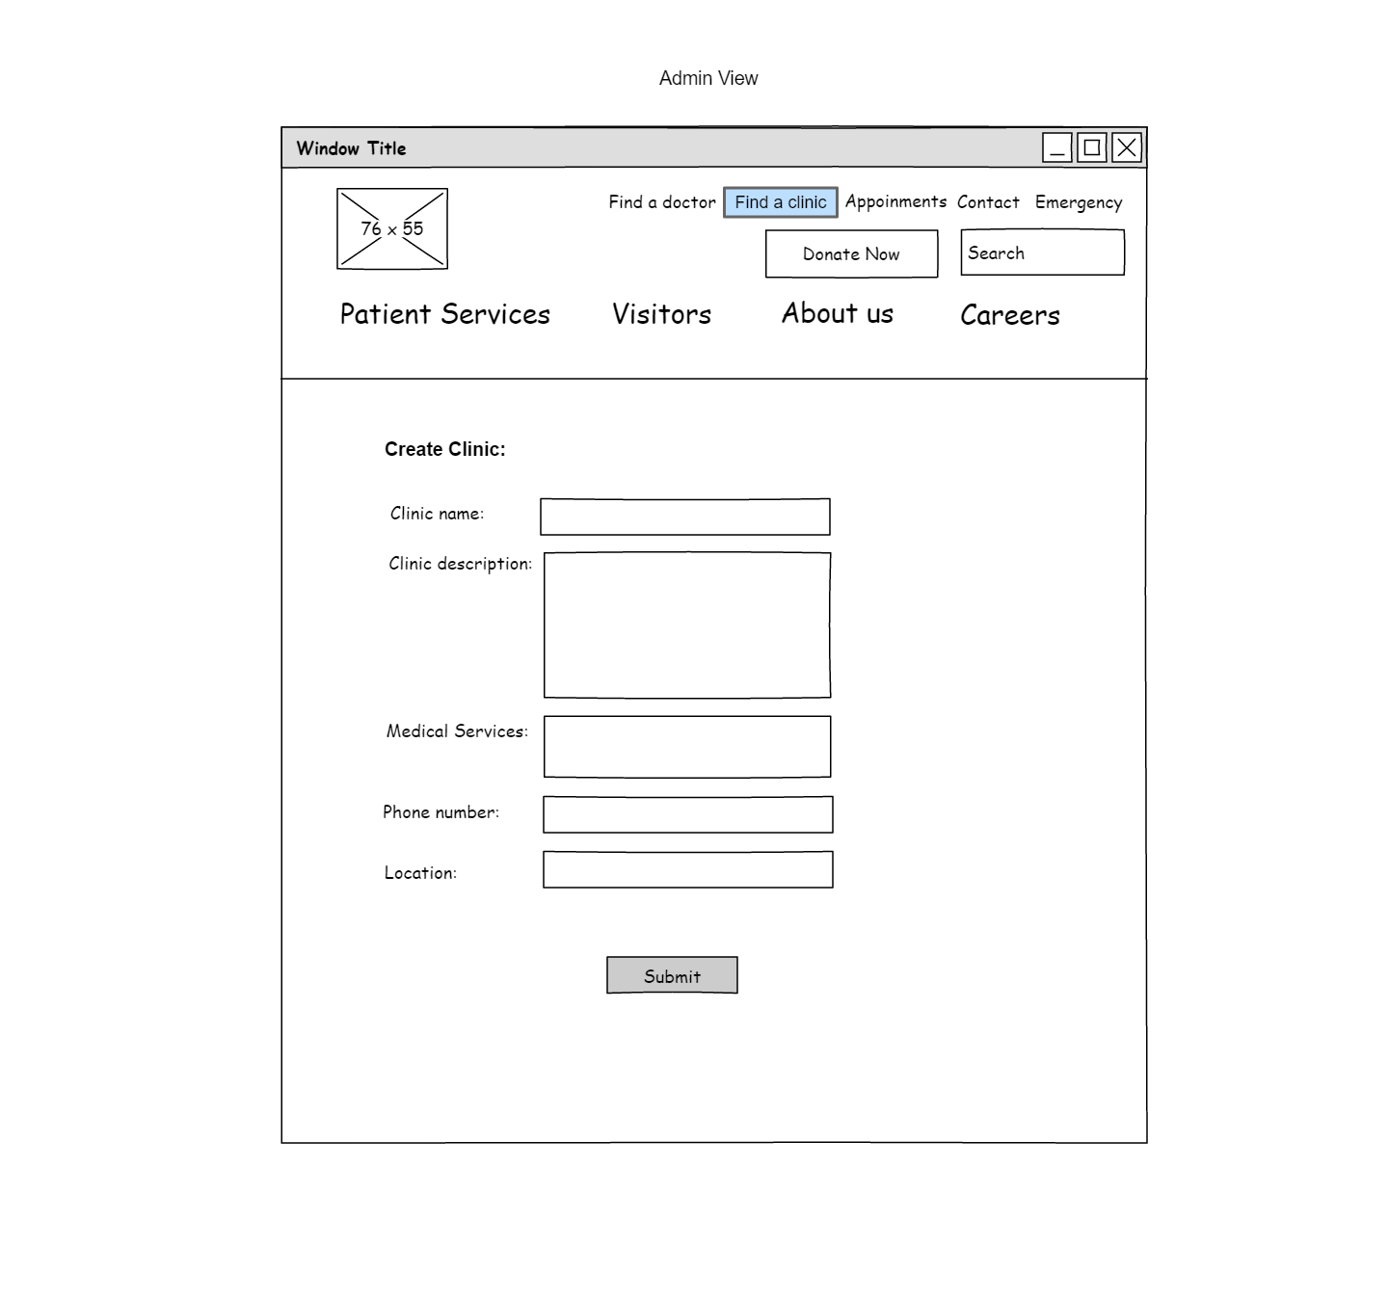

**Fig 4:** Create clinic admin wireframe

1. **Admin view:** An admin is editing an existing clinic

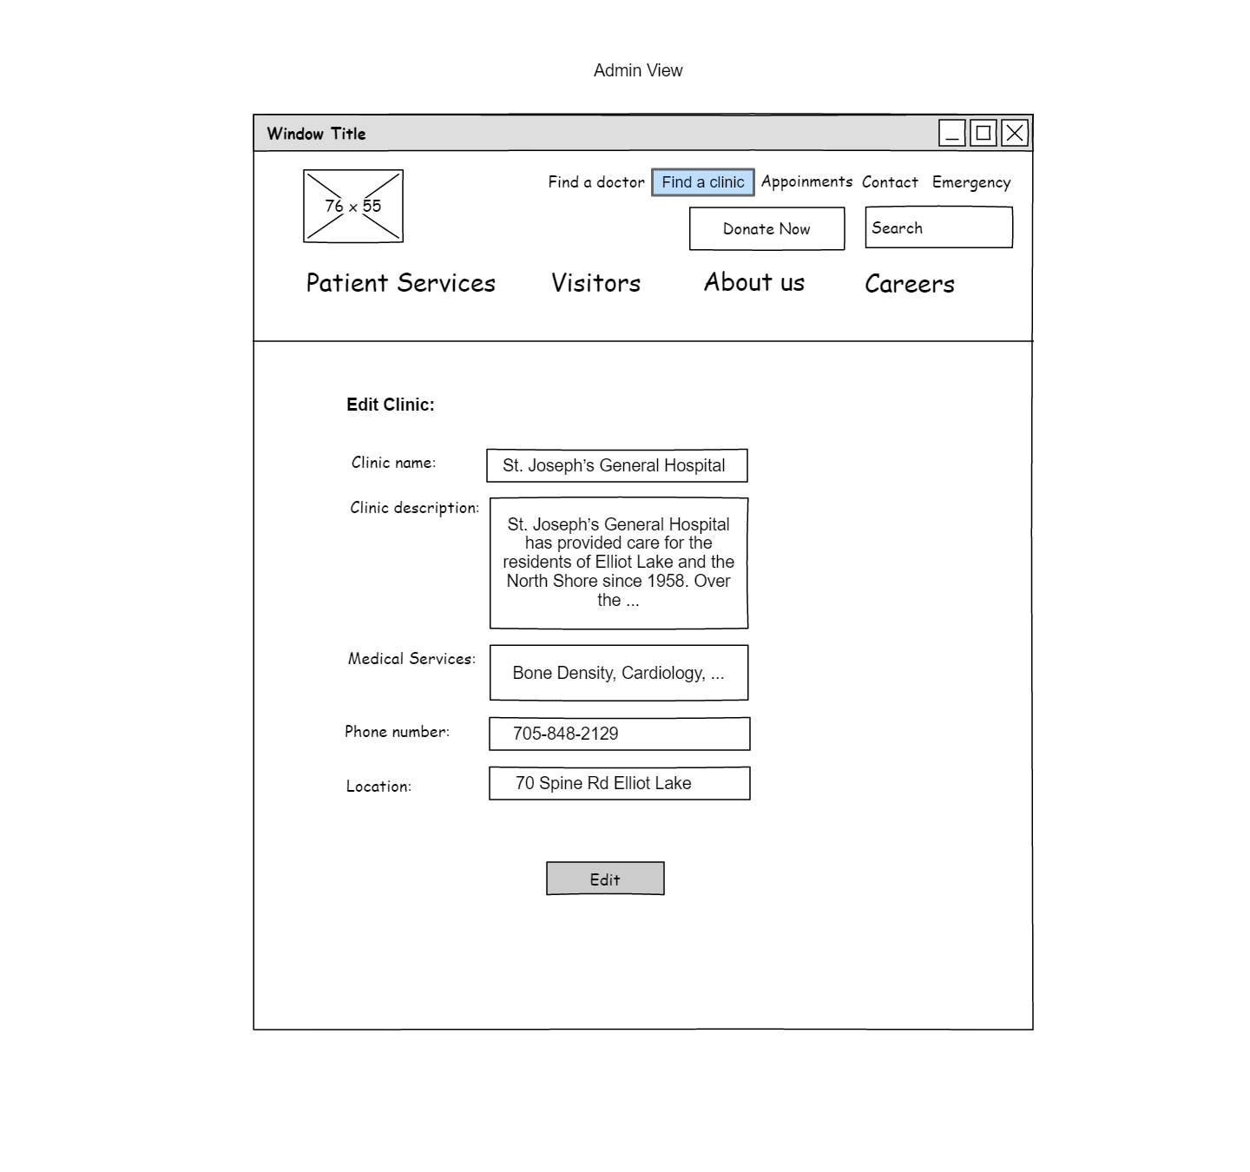

**Fig 5:** Edit clinic admin wireframe

1. **Admin View:** An admin is deleting a clinic

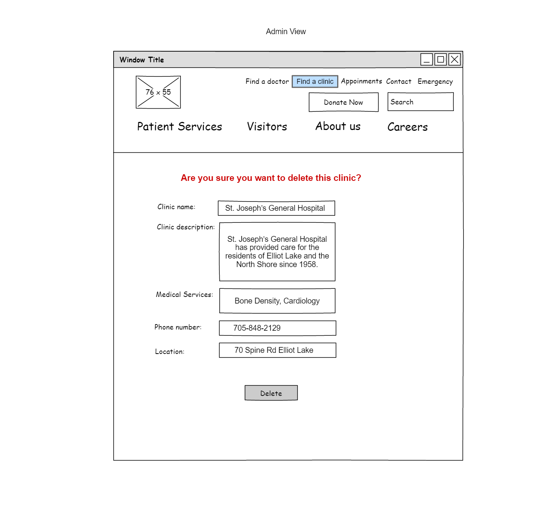

**Fig 6:** Delete clinic admin wireframe

1. **Medical services**

The Medical Services feature allows a user to access all the medical services, including the outpatient and inpatient services on the same page. The list of services the hospital offers is a lot. The user can either scroll down the page to see the services or can use the search bar to find a specific service.

1. **Public view:** A user searching for a medical service

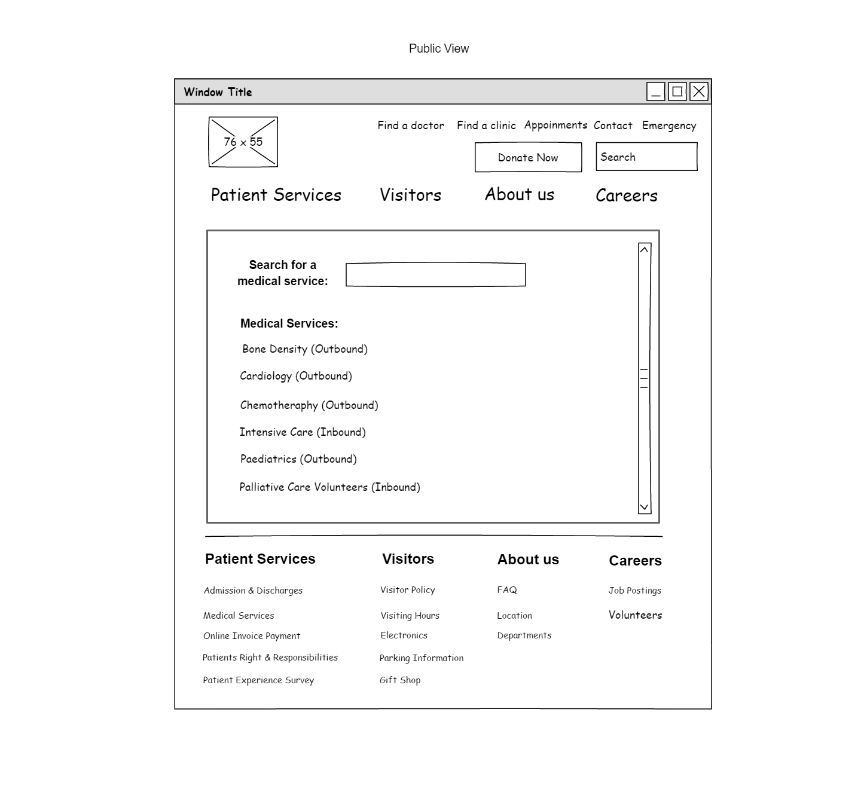

**Fig 7:** Medical Services public wireframe

1. **Admin view:** An admin is adding a new medical service

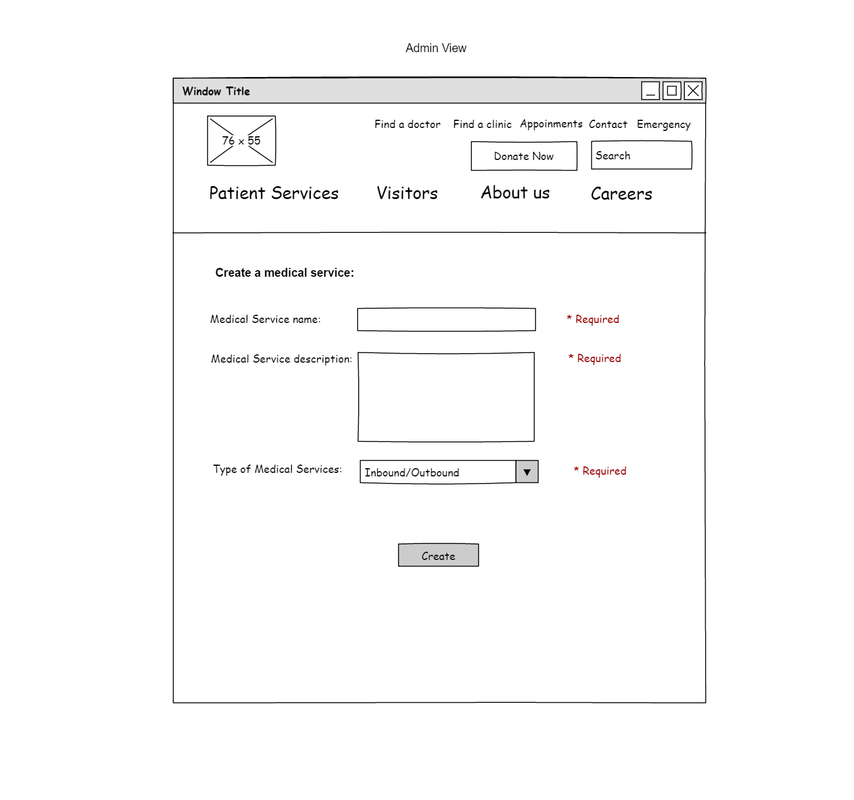

**Fig 8:** Create amedical Service admin dataflow

1. **Admin view:** An admin is editing an existing medical service

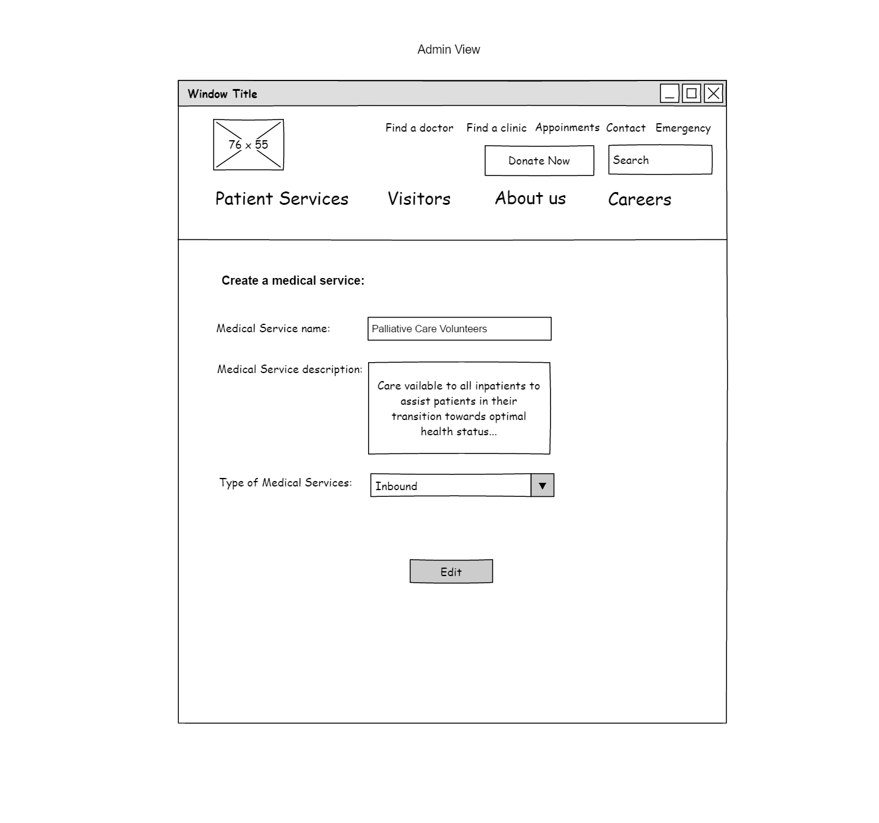

**Fig 9:** Edit amedical Service admin wireframe

1. **Admin view:** An admin is deleting an existing medical service

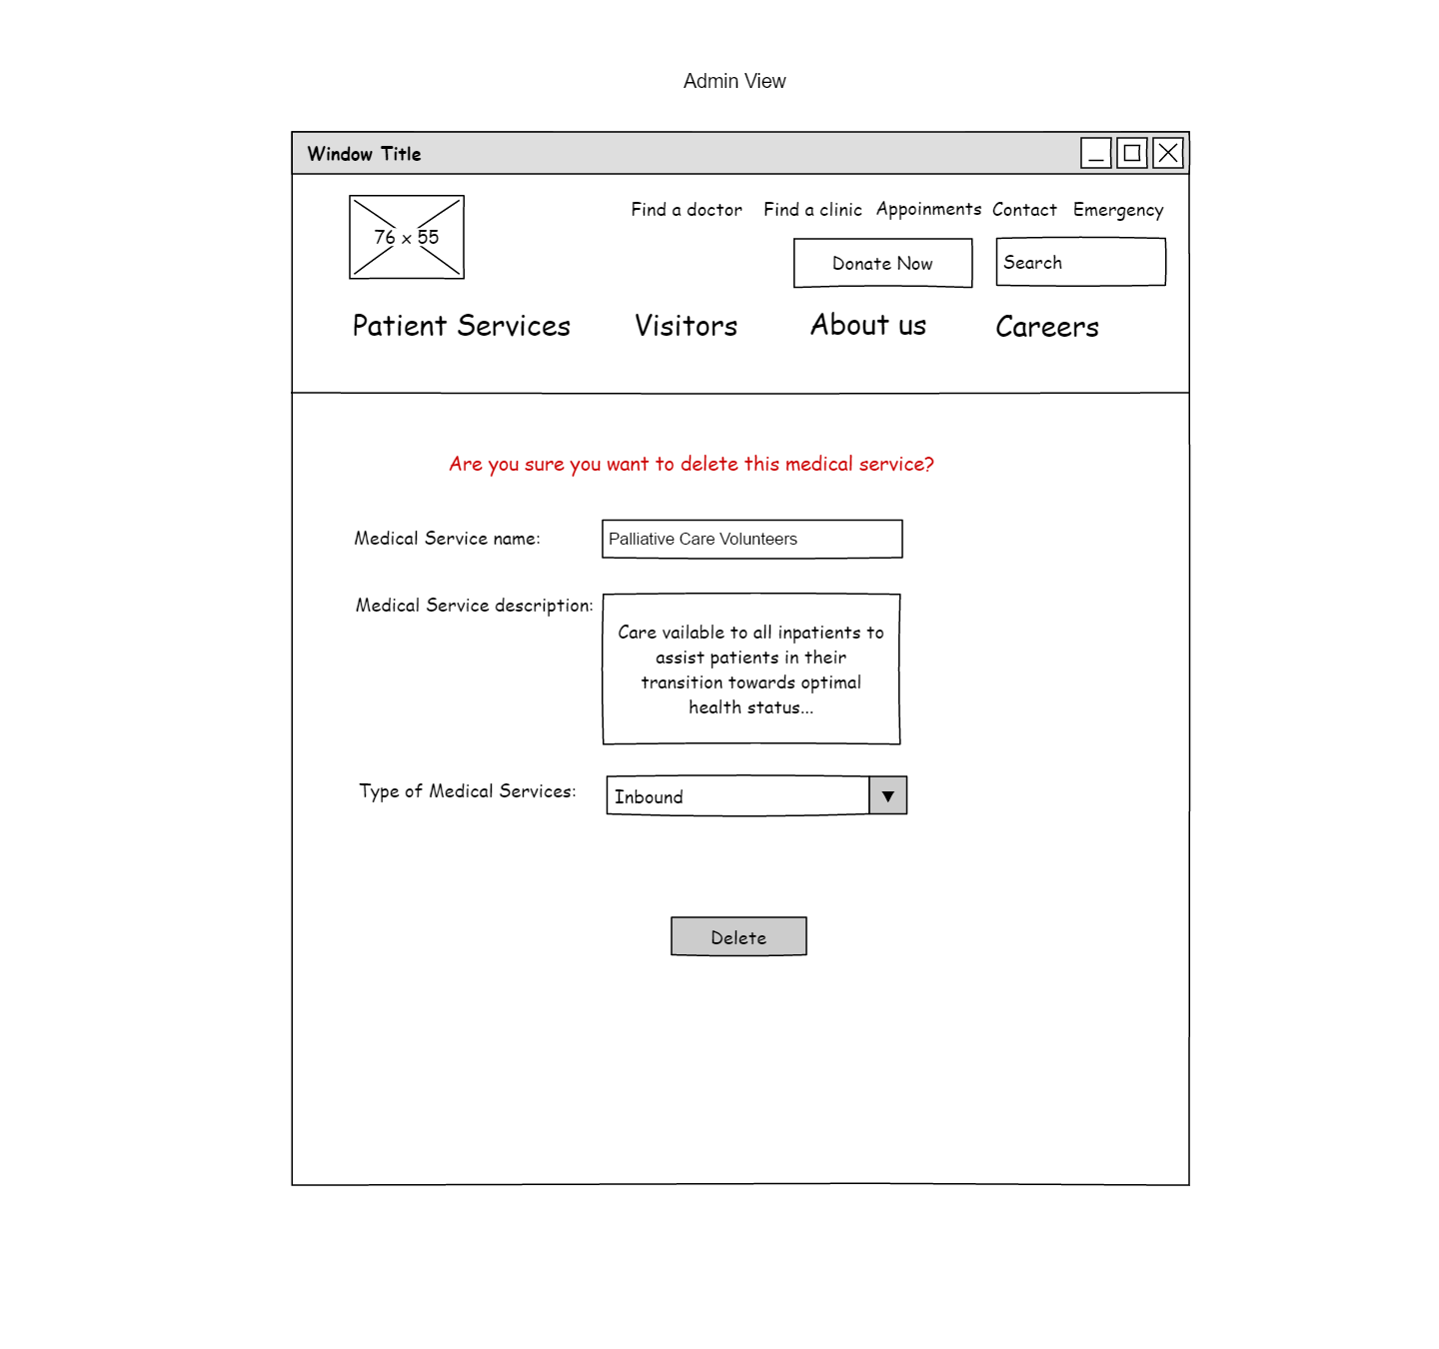

**Fig 10:** Delete amedical Service admin wireframe